Geometry: Unit 12, Lesson 3
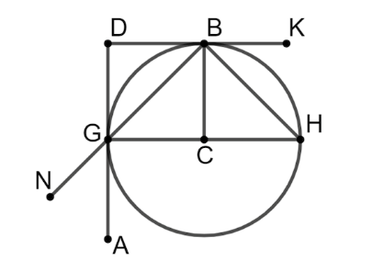
- Circle $C$ is shown with points $B, H,$ and $G$ on the circle and points $K, D, N,$ and $A$ outside the circle. Give a segment that is tangent to circle $C$?

$$\overline{DG }, \overline{KD}$$

- $H, K,$ and $P$ are collinear points, where point $H$ is between points $K$ and $P$. $KH=x$ units, $PH=x+ 2$ units, and $KP=24$ units. What is the length of $\overline{HP}$?

$$HP=13 units$$

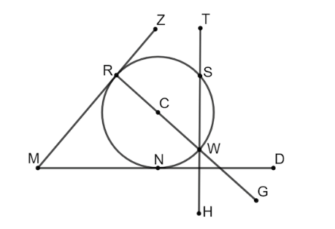
- Circle $C$ is shown with points $R, S, W,$ and $N$ on the circle and points $Z,T,D,G,H,$ and $M$ outside the circle.

$$\overline{MZ}, \overline{DM}$$

